VEHICLE SERVICE MANAGEMENT SYSTEM USING CRUD OPERATION
Name: N HARISH
USN/ID: SCA24CA0053
Class/Semester: 3rd Year-5th Sem

1. Introduction
The Vehicle Service Management System is a web-based application developed to manage vehicle service records digitally. The system allows the user to add, view, update and delete vehicle service information.
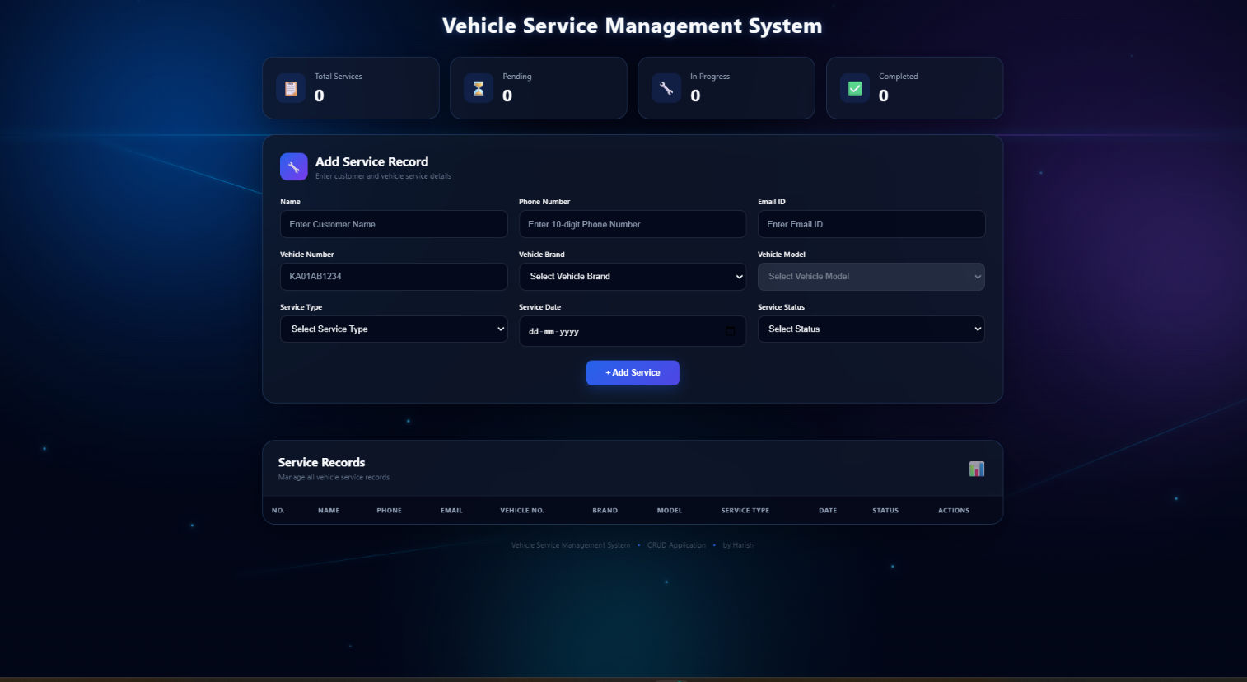
The application stores service records in a MySQL database and uses Node.js and Express.js for backend operations. HTML, CSS and JavaScript are used to create the user interface.

2. Technologies Used

The following technologies are used in this project:

Technology | Purpose
HTML | Creates the structure of the webpage
CSS | Designs and styles the application
JavaScript | Handles frontend functionality
Node.js | Runs the backend server
Express.js | Creates the REST API
MySQL | Stores service records
MySQL Workbench | Manages the database
VS Code | Used for development

3. Project Structure
The project contains the following files:
crud_project/
│
├── public/
│ ├── index.html
│ ├── style.css
│ └── script.js
│
├── db.js
├── server.js
├── schema.sql
├── package.json
└── package-lock.json
--------------------------------------------------------------------------------------------------------------

4.index.html
<!DOCTYPE html>
<html lang="en">

<head>

<meta charset="UTF-8">

<meta
name="viewport"
content="width=device-width, initial-scale=1.0"
>

<title>
Vehicle Service Management System
</title>

<link
rel="stylesheet"
href="style.css"
>

</head>

<body>

<!-- =========================================
GRAPHICAL BACKGROUND
========================================== -->

<div class="animated-background">

<div class="aurora aurora-1"></div>

<div class="aurora aurora-2"></div>

<div class="aurora aurora-3"></div>

<div class="tech-grid"></div>

<div class="circuit circuit-1"></div>

<div class="circuit circuit-2"></div>

<div class="circuit circuit-3"></div>

<div class="particles">

<span></span>
<span></span>
<span></span>
<span></span>
<span></span>
<span></span>
<span></span>
<span></span>
<span></span>
<span></span>

<span></span>
<span></span>
<span></span>
<span></span>
<span></span>
<span></span>
<span></span>
<span></span>
<span></span>
<span></span>

</div>

</div>

<!-- =========================================
MAIN CONTAINER
========================================== -->

<div class="container">

<!-- =========================================
TITLE
========================================== -->

<header class="header">

<h1>
Vehicle Service Management System
</h1>

</header>

<!-- =========================================
DASHBOARD
========================================== -->

<div class="dashboard">

<div class="stat-card">

<div class="stat-icon">
📋
</div>

<div>

<div class="stat-title">
Total Services
</div>

<div
class="stat-number"
id="totalCount"
>
0
</div>

</div>

</div>

<div class="stat-card">

<div class="stat-icon">
⏳
</div>

<div>

<div class="stat-title">
Pending
</div>

<div
class="stat-number"
id="pendingCount"
>
0
</div>

</div>

</div>

<div class="stat-card">

<div class="stat-icon">
🔧
</div>

<div>

<div class="stat-title">
In Progress
</div>

<div
class="stat-number"
id="progressCount"
>
0
</div>

</div>

</div>

<div class="stat-card">

<div class="stat-icon">
✅
</div>

<div>

<div class="stat-title">
Completed
</div>

<div
class="stat-number"
id="completedCount"
>
0
</div>

</div>

</div>

</div>

<!-- =========================================
SERVICE FORM
========================================== -->

<div class="form-box">

<div class="section-title">

<div class="section-icon">
🔧
</div>

<div>

<h2 id="formTitle">
Add Service Record
</h2>

<p>
Enter customer and vehicle service details
</p>

</div>

</div>

<form id="serviceForm">

<!-- NAME -->

<div class="input-group">

<label>
Name
</label>

<input
type="text"
id="customer_name"
placeholder="Enter Customer Name"
required
>

</div>

<!-- PHONE -->

<div class="input-group">

<label>
Phone Number
</label>

<input
type="tel"
id="phone_number"
placeholder="Enter 10-digit Phone Number"
maxlength="10"
inputmode="numeric"
required
>

</div>

<!-- EMAIL -->

<div class="input-group">

<label>
Email ID
</label>

<input
type="email"
id="email_id"
placeholder="Enter Email ID"
required
>

</div>

<!-- VEHICLE NUMBER -->

<div class="input-group">

<label>
Vehicle Number
</label>

<input
type="text"
id="vehicle_number"
placeholder="KA01AB1234"
maxlength="30"
required
>

</div>

<!-- BRAND -->

<div class="input-group">

<label>
Vehicle Brand
</label>

<select
id="vehicle_brand"
onchange="updateModels()"
required
>

<option value="">
Select Vehicle Brand
</option>

<option value="Royal Enfield">
Royal Enfield
</option>

<option value="Honda">
Honda
</option>

<option value="Yamaha">
Yamaha
</option>

<option value="TVS">
TVS
</option>

<option value="Bajaj">
Bajaj
</option>

<option value="Hero">
Hero
</option>

<option value="KTM">
KTM
</option>

<option value="Suzuki">
Suzuki
</option>

</select>

</div>

<!-- MODEL -->

<div class="input-group">

<label>
Vehicle Model
</label>

<select
id="vehicle_model"
disabled
required
>

<option value="">
Select Vehicle Model
</option>

</select>

</div>

<!-- SERVICE TYPE -->

<div class="input-group">

<label>
Service Type
</label>

<select
id="service_type"
required
>

<option value="">
Select Service Type
</option>

<option value="General Service">
General Service
</option>

<option value="Oil Change">
Oil Change
</option>

<option value="Engine Service">
Engine Service
</option>

<option value="Brake Service">
Brake Service
</option>

<option value="Tyre Service">
Tyre Service
</option>

<option value="Battery Service">
Battery Service
</option>

<option value="Wheel Alignment">
Wheel Alignment
</option>

<option value="Wheel Balancing">
Wheel Balancing
</option>

<option value="Clutch Service">
Clutch Service
</option>

<option value="Full Body Service">
Full Body Service
</option>

<option value="Other">
Other
</option>

</select>

</div>

<!-- DATE -->

<div class="input-group">

<label>
Service Date
</label>

<input
type="date"
id="service_date"
required
>

</div>

<!-- STATUS -->

<div class="input-group">

<label>
Service Status
</label>

<select
id="service_status"
required
>

<option value="">
Select Status
</option>

<option value="Pending">
Pending
</option>

<option value="In Progress">
In Progress
</option>

<option value="Completed">
Completed
</option>

</select>

</div>

<!-- BUTTONS -->

<div class="form-buttons">

<button
type="submit"
id="submitButton"
class="add-btn"
>
+ Add Service
</button>

<button
type="button"
id="cancelButton"
class="cancel-btn"
onclick="cancelEdit()"
>
Cancel
</button>

</div>

</form>

</div>

<!-- MESSAGE -->

<div id="message"></div>

<!-- =========================================
SERVICE RECORD TABLE
========================================== -->

<div class="table-container">

<div class="table-header">

<div>

<h2>
Service Records
</h2>

<p>
Manage all vehicle service records
</p>

</div>

<div class="record-icon">
📊
</div>

</div>

<div class="table-scroll">

<table>

<thead>

<tr>

<th>No.</th>

<th>Name</th>

<th>Phone</th>

<th>Email</th>

<th>Vehicle No.</th>

<th>Brand</th>

<th>Model</th>

<th>Service Type</th>

<th>Date</th>

<th>Status</th>

<th>Actions</th>

</tr>

</thead>

<tbody id="serviceTable">

</tbody>

</table>

</div>

</div>

<!-- FOOTER -->

<footer>

Vehicle Service Management System

<span>•</span>

CRUD Application

<span>•</span>

by Harish

</footer>

</div>

<script src="script.js"></script>

</body>

</html>

--------------------------------------------------------------------------------------------------------------

5. style.css

* {
box-sizing: border-box;
margin: 0;
padding: 0;
}

html {
scroll-behavior: smooth;
}

body {
font-family: "Segoe UI", Arial, sans-serif;
color: #e2e8f0;
min-height: 100vh;
overflow-x: hidden;

background:
radial-gradient(
circle at 15% 20%,
rgba(0, 119, 255, 0.25),
transparent 30%
),
radial-gradient(
circle at 85% 30%,
rgba(124, 58, 237, 0.22),
transparent 32%
),
radial-gradient(
circle at 50% 90%,
rgba(6, 182, 212, 0.15),
transparent 30%
),
#020617;
}

/* =========================================
GRAPHICAL BACKGROUND
========================================= */

.animated-background {
position: fixed;
inset: 0;
width: 100%;
height: 100%;
overflow: hidden;
pointer-events: none;
z-index: 0;
}

.animated-background::after {
content: "";
position: absolute;
inset: 0;

background:
linear-gradient(
180deg,
rgba(2, 6, 23, 0.08),
rgba(2, 6, 23, 0.38)
);

z-index: 5;
}

/* =========================================
AURORA
========================================= */

.aurora {
position: absolute;
border-radius: 50%;
filter: blur(80px);
opacity: 0.55;
}

.aurora-1 {
width: 500px;
height: 500px;

left: -150px;
top: -120px;

background:
radial-gradient(
circle,
rgba(0, 119, 255, 0.85),
transparent 70%
);

animation:
auroraBlue 12s ease-in-out infinite;
}

.aurora-2 {
width: 550px;
height: 550px;

right: -180px;
top: 15%;

background:
radial-gradient(
circle,
rgba(139, 92, 246, 0.7),
transparent 70%
);

animation:
auroraPurple 15s ease-in-out infinite;
}

.aurora-3 {
width: 500px;
height: 500px;

left: 35%;
bottom: -250px;

background:
radial-gradient(
circle,
rgba(6, 182, 212, 0.65),
transparent 70%
);

animation:
auroraCyan 18s ease-in-out infinite;
}

/* =========================================
AURORA ANIMATION
========================================= */

@keyframes auroraBlue {

0% {
transform: translate(0, 0) scale(1);
}

50% {
transform: translate(220px, 120px) scale(1.35);
}

100% {
transform: translate(0, 0) scale(1);
}
}

@keyframes auroraPurple {

0% {
transform: translate(0, 0) scale(1);
}

50% {
transform: translate(-180px, 100px) scale(1.3);
}

100% {
transform: translate(0, 0) scale(1);
}
}

@keyframes auroraCyan {

0% {
transform: translate(0, 0) scale(1);
}

50% {
transform: translate(160px, -130px) scale(1.3);
}

100% {
transform: translate(0, 0) scale(1);
}
}

/* =========================================
TECHNOLOGY GRID
========================================= */

.tech-grid {
position: absolute;

width: 150%;
height: 150%;

left: -25%;
top: -10%;

opacity: 0.42;

background-image:
linear-gradient(
rgba(59, 130, 246, 0.15) 1px,
transparent 1px
),
linear-gradient(
90deg,
rgba(59, 130, 246, 0.15) 1px,
transparent 1px
);

background-size: 55px 55px;

transform:
perspective(500px)
rotateX(55deg)
scale(1.4);

transform-origin: center bottom;

animation:
gridMove 12s linear infinite;
}

@keyframes gridMove {

from {
background-position: 0 0;
}

to {
background-position: 0 55px;
}
}

/* =========================================
LIGHT SCANNER
========================================= */

.animated-background::before {
content: "";

position: absolute;

left: 0;
right: 0;

height: 2px;

top: 10%;

background:
linear-gradient(
90deg,
transparent,
rgba(0, 183, 255, 0.9),
rgba(139, 92, 246, 0.9),
transparent
);

box-shadow:
0 0 15px
rgba(0, 183, 255, 0.8);

opacity: 0.6;

animation:
scannerMove 7s linear infinite;

z-index: 6;
}

@keyframes scannerMove {

0% {
top: 10%;
opacity: 0;
}

20% {
opacity: 0.7;
}

50% {
opacity: 0.4;
}

80% {
opacity: 0.7;
}

100% {
top: 90%;
opacity: 0;
}
}

/* =========================================
CIRCUIT LINES
========================================= */

.circuit {
position: absolute;

height: 1px;

background:
linear-gradient(
90deg,
transparent,
rgba(0, 183, 255, 0.9),
transparent
);

box-shadow:
0 0 10px
rgba(0, 183, 255, 0.8);

opacity: 0.6;
}

.circuit-1 {
width: 500px;
top: 28%;
left: -100px;

transform: rotate(18deg);

animation:
circuitMove1 8s ease-in-out infinite;
}

.circuit-2 {
width: 600px;
top: 65%;
right: -180px;

transform: rotate(-22deg);

animation:
circuitMove2 10s ease-in-out infinite;
}

.circuit-3 {
width: 450px;
top: 82%;
left: 15%;

transform: rotate(-8deg);

animation:
circuitMove3 9s ease-in-out infinite;
}

@keyframes circuitMove1 {

0%,
100% {
transform:
translateX(0)
rotate(18deg);

opacity: 0.2;
}

50% {
transform:
translateX(250px)
rotate(18deg);

opacity: 0.8;
}
}

@keyframes circuitMove2 {

0%,
100% {
transform:
translateX(0)
rotate(-22deg);

opacity: 0.2;
}

50% {
transform:
translateX(-250px)
rotate(-22deg);

opacity: 0.8;
}
}

@keyframes circuitMove3 {

0%,
100% {
transform:
translateX(0)
rotate(-8deg);

opacity: 0.15;
}

50% {
transform:
translateX(200px)
rotate(-8deg);

opacity: 0.7;
}
}

/* =========================================
PARTICLES
========================================= */

.particles {
position: absolute;
inset: 0;
}

.particles span {
position: absolute;

width: 3px;
height: 3px;

border-radius: 50%;

background: #38bdf8;

box-shadow:
0 0 5px #38bdf8,
0 0 15px #0ea5e9,
0 0 25px #2563eb;

bottom: -20px;

animation:
particleFloat
linear infinite;
}

/* =========================================
PARTICLE POSITIONS
========================================= */

.particles span:nth-child(1) {
left: 4%;
animation-duration: 11s;
animation-delay: 1s;
}

.particles span:nth-child(2) {
left: 9%;
animation-duration: 15s;
animation-delay: 3s;
}

.particles span:nth-child(3) {
left: 15%;
animation-duration: 12s;
animation-delay: 5s;
}

.particles span:nth-child(4) {
left: 21%;
animation-duration: 18s;
animation-delay: 2s;
}

.particles span:nth-child(5) {
left: 27%;
animation-duration: 14s;
animation-delay: 7s;
}

.particles span:nth-child(6) {
left: 33%;
animation-duration: 20s;
animation-delay: 4s;
}

.particles span:nth-child(7) {
left: 40%;
animation-duration: 13s;
animation-delay: 8s;
}

.particles span:nth-child(8) {
left: 46%;
animation-duration: 17s;
animation-delay: 2s;
}

.particles span:nth-child(9) {
left: 52%;
animation-duration: 12s;
animation-delay: 6s;
}

.particles span:nth-child(10) {
left: 58%;
animation-duration: 19s;
animation-delay: 3s;
}

.particles span:nth-child(11) {
left: 64%;
animation-duration: 14s;
animation-delay: 9s;
}

.particles span:nth-child(12) {
left: 70%;
animation-duration: 16s;
animation-delay: 1s;
}

.particles span:nth-child(13) {
left: 76%;
animation-duration: 13s;
animation-delay: 5s;
}

.particles span:nth-child(14) {
left: 82%;
animation-duration: 18s;
animation-delay: 7s;
}

.particles span:nth-child(15) {
left: 88%;
animation-duration: 15s;
animation-delay: 4s;
}

.particles span:nth-child(16) {
left: 93%;
animation-duration: 21s;
animation-delay: 2s;
}

.particles span:nth-child(17) {
left: 18%;
animation-duration: 19s;
animation-delay: 10s;
}

.particles span:nth-child(18) {
left: 48%;
animation-duration: 16s;
animation-delay: 11s;
}

.particles span:nth-child(19) {
left: 68%;
animation-duration: 20s;
animation-delay: 5s;
}

.particles span:nth-child(20) {
left: 96%;
animation-duration: 14s;
animation-delay: 8s;
}

@keyframes particleFloat {

0% {
transform:
translateY(0)
translateX(0)
scale(0);

opacity: 0;
}

10% {
opacity: 1;

transform:
translateY(-10vh)
translateX(20px)
scale(1);
}

50% {
opacity: 0.8;

transform:
translateY(-50vh)
translateX(-30px)
scale(1.4);
}

100% {
opacity: 0;

transform:
translateY(-110vh)
translateX(50px)
scale(0.5);
}
}

/* =========================================
MAIN CONTAINER
========================================= */

.container {
position: relative;

z-index: 10;

max-width: 1250px;

margin: 0 auto;

padding:
20px 25px 25px;
}

/* =========================================
CENTERED TITLE
========================================= */

.header {
position: relative;

width: 100vw;

margin-left:
calc(50% - 50vw);

display: flex;

justify-content: center;

align-items: center;

text-align: center;

margin-bottom: 30px;
}

.header h1 {
width: 100%;

margin: 0;
padding: 0;

text-align: center;

font-size: 34px;

font-weight: 700;

color: #f8fafc;

letter-spacing: 1px;

text-shadow:
0 0 10px
rgba(96, 165, 250, 0.35),

0 0 25px
rgba(37, 99, 235, 0.15);
}

/* =========================================
DASHBOARD
========================================= */

.dashboard {
display: grid;

grid-template-columns:
repeat(4, 1fr);

gap: 18px;

margin-bottom: 25px;
}

.stat-card {
display: flex;

align-items: center;

gap: 15px;

padding: 21px;

background:
rgba(15, 23, 42, 0.80);

backdrop-filter:
blur(18px);

-webkit-backdrop-filter:
blur(18px);

border:
1px solid
rgba(96, 165, 250, 0.20);

border-radius: 18px;

box-shadow:
0 10px 40px
rgba(0, 0, 0, 0.30);

transition:
transform 0.3s,
box-shadow 0.3s;
}

.stat-card:hover {
transform:
translateY(-5px);

box-shadow:
0 15px 45px
rgba(37, 99, 235, 0.28);
}

.stat-icon {
width: 48px;
height: 48px;

display: flex;

align-items: center;
justify-content: center;

background:
rgba(37, 99, 235, 0.15);

border-radius: 12px;

font-size: 23px;
}

.stat-title {
color: #94a3b8;

font-size: 13px;

margin-bottom: 5px;
}

.stat-number {
font-size: 27px;

font-weight: 700;

color: #f8fafc;
}

/* =========================================
FORM BOX
========================================= */

.form-box {
background:
rgba(15, 23, 42, 0.82);

backdrop-filter:
blur(18px);

-webkit-backdrop-filter:
blur(18px);

padding: 28px;

border-radius: 20px;

border:
1px solid
rgba(96, 165, 250, 0.22);

box-shadow:
0 15px 50px
rgba(0, 0, 0, 0.30);

margin-bottom: 25px;
}

/* =========================================
SECTION TITLE
========================================= */

.section-title {
display: flex;

align-items: center;

gap: 13px;

margin-bottom: 25px;
}

.section-icon {
width: 44px;
height: 44px;

display: flex;

align-items: center;
justify-content: center;

background:
linear-gradient(
135deg,
#2563eb,
#7c3aed
);

border-radius: 12px;

font-size: 20px;
}

.section-title h2 {
color: #f8fafc;

font-size: 20px;
}

.section-title p {
color: #64748b;

font-size: 12px;

margin-top: 3px;
}

/* =========================================
FORM GRID
========================================= */

#serviceForm {
display: grid;

grid-template-columns:
repeat(3, 1fr);

gap: 18px;
}

.input-group {
display: flex;

flex-direction: column;

gap: 7px;
}

.input-group label {
color: #fefefe;

font-size: 12px;

font-weight: 600;
}

/* =========================================
INPUTS AND SELECTS
========================================= */

input,
select {
width: 100%;

padding:
13px 14px;

border:
1px solid
rgba(148, 163, 184, 0.20);

border-radius: 10px;

/*
Dark input background
with clear white text
*/
background:
rgba(2, 6, 23, 0.75);

color: #f8fafc;

font-size: 14px;

outline: none;

transition:
border-color 0.25s,
box-shadow 0.25s,
background 0.25s;
}

/* =========================================
PLACEHOLDER
========================================= */

input::placeholder {
color: #94a3b8;
}

/* =========================================
DROPDOWN OPTIONS
========================================= */

select option {
background: #0f172a;

color: #f8fafc;
}

/* =========================================
FOCUS
========================================= */

input:focus,
select:focus {
border-color: #3b82f6;

background:
rgba(2, 6, 23, 0.90);

box-shadow:
0 0 0 3px
rgba(59, 130, 246, 0.12),

0 0 18px
rgba(37, 99, 235, 0.18);
}

/* =========================================
ENABLED INPUTS AND SELECTS
========================================= */

input:not(:disabled),
select:not(:disabled) {
opacity: 1;

color: #f8fafc;
}

/* =========================================
DISABLED CONTROL
========================================= */

input:disabled,
select:disabled {
opacity: 0.55;

cursor: not-allowed;
}

/*
Vehicle Model is intentionally disabled
until a Vehicle Brand is selected.
*/
#vehicle_model:disabled {
background:
rgba(71, 85, 105, 0.65);

color: #cbd5e1;
}

/* =========================================
DATE INPUT
========================================= */

input[type="date"] {
color-scheme: dark;

cursor: pointer;

color: #f8fafc;

opacity: 1;
}

input[type="date"]:not(:disabled) {
color: #f8fafc;

opacity: 1;
}

input[type="date"]::-webkit-calendar-picker-indicator {
opacity: 1;

visibility: visible;

display: block;

cursor: pointer;

filter: invert(1);

width: 18px;

height: 18px;

padding: 2px;
}

input[type="date"]::-webkit-datetime-edit {
color: #f8fafc;
}

input[type="date"]::-webkit-datetime-edit-fields-wrapper {
color: #f8fafc;
}

input[type="date"]::-webkit-datetime-edit-text {
color: #94a3b8;
}

input[type="date"]::-webkit-datetime-edit-month-field,
input[type="date"]::-webkit-datetime-edit-day-field,
input[type="date"]::-webkit-datetime-edit-year-field {
color: #f8fafc;
}

input[type="date"]::-webkit-calendar-picker-indicator:hover {
filter:
invert(1)
drop-shadow(
0 0 5px #38bdf8
);
}

/* =========================================
FORM BUTTONS
EXACT CENTER OF FORM
========================================= */

.form-buttons {

grid-column: 1 / -1;

display: flex;

justify-content: center;

align-items: center;

width: 100%;

gap: 10px;

margin-top: 4px;
}

/* =========================================
GENERAL BUTTON
========================================= */

button {
border: none;

border-radius: 9px;

padding:
12px 19px;

cursor: pointer;

font-weight: 600;

transition:
transform 0.25s,
box-shadow 0.25s,
background 0.25s;
}

/* =========================================
ADD SERVICE BUTTON
========================================= */

.form-buttons .add-btn {

display: block;

min-width: 150px;

padding:
13px 25px;

margin: 0;

text-align: center;

color: white;

background:
linear-gradient(
135deg,
#2563eb,
#4f46e5
);

box-shadow:
0 6px 20px
rgba(37, 99, 235, 0.30);
}

.form-buttons .add-btn:hover {

transform:
translateY(-2px);

box-shadow:
0 10px 28px
rgba(37, 99, 235, 0.45);
}

/* =========================================
UPDATE BUTTON
========================================= */

.form-buttons .update-btn {

min-width: 150px;

padding:
13px 25px;

color: white;

background:
linear-gradient(
135deg,
#16a34a,
#15803d
);
}

.form-buttons .update-btn:hover {

transform:
translateY(-2px);

box-shadow:
0 10px 28px
rgba(22, 163, 74, 0.35);
}

/* =========================================
CANCEL BUTTON
========================================= */

.form-buttons .cancel-btn {

min-width: 100px;

color: white;

background: #475569;

display: none;
}

/* =========================================
MESSAGE
========================================= */

#message {
text-align: center;

min-height: 22px;

font-size: 14px;

font-weight: 600;

margin:
12px 0;
}

/* =========================================
TABLE
========================================= */

.table-container {
background:
rgba(15, 23, 42, 0.82);

backdrop-filter:
blur(18px);

-webkit-backdrop-filter:
blur(18px);

border-radius: 20px;

overflow: hidden;

border:
1px solid
rgba(96, 165, 250, 0.22);

box-shadow:
0 15px 50px
rgba(0, 0, 0, 0.30);
}

.table-header {
display: flex;

justify-content: space-between;

align-items: center;

padding:
22px 25px;

border-bottom:
1px solid
rgba(148, 163, 184, 0.10);
}

.table-header h2 {
font-size: 19px;

color: #f8fafc;
}

.table-header p {
color: #64748b;

font-size: 12px;

margin-top: 4px;
}

.record-icon {
font-size: 25px;

opacity: 0.7;
}

/* =========================================
TABLE SCROLL
========================================= */

.table-scroll {
overflow-x: auto;
}

table {
width: 100%;

min-width: 1150px;

border-collapse: collapse;
}

thead {
background:
rgba(2, 6, 23, 0.78);
}

th {
color: #94a3b8;

padding: 15px;

text-align: left;

font-size: 11px;

text-transform: uppercase;

letter-spacing: 0.5px;

white-space: nowrap;
}

td {
padding: 15px;

color: #cbd5e1;

border-bottom:
1px solid
rgba(148, 163, 184, 0.08);

font-size: 13px;

white-space: nowrap;
}

tbody tr {
transition: 0.2s;
}

tbody tr:hover {
background:
rgba(37, 99, 235, 0.10);
}

/* =========================================
EDIT BUTTON
========================================= */

.edit-btn {
background:
rgba(245, 158, 11, 0.15);

color: #fbbf24;

border:
1px solid
rgba(245, 158, 11, 0.25);

padding:
7px 11px;

font-size: 11px;

margin-right: 4px;
}

.edit-btn:hover {
background:
rgba(245, 158, 11, 0.25);
}

/* =========================================
DELETE BUTTON
========================================= */

.delete-btn {
background:
rgba(239, 68, 68, 0.15);

color: #f87171;

border:
1px solid
rgba(239, 68, 68, 0.25);

padding:
7px 11px;

font-size: 11px;
}

.delete-btn:hover {
background:
rgba(239, 68, 68, 0.25);
}

/* =========================================
FOOTER
========================================= */

footer {
text-align: center;

padding: 25px;

color: #475569;

font-size: 12px;
}

footer span {
margin:
0 8px;

color: #2563eb;
}

/* =========================================
TABLET
========================================= */

@media (max-width: 1000px) {

.dashboard {
grid-template-columns:
repeat(2, 1fr);
}

#serviceForm {
grid-template-columns:
repeat(2, 1fr);
}

.form-buttons {
grid-column: 1 / -1;
}
}

/* =========================================
MOBILE
========================================= */

@media (max-width: 650px) {

.container {
padding:
20px 12px 25px;
}

.header {
width: 100vw;

margin-left:
calc(50% - 50vw);

margin-bottom: 25px;
}

.header h1 {
font-size: 25px;

padding:
0 15px;
}

.dashboard {
grid-template-columns: 1fr;
}

#serviceForm {
grid-template-columns: 1fr;
}

.form-box {
padding: 20px;
}

.table-header {
padding: 18px;
}

.form-buttons {
grid-column: 1 / -1;

justify-content: center;

width: 100%;
}

.form-buttons .add-btn,
.form-buttons .update-btn {
min-width: 150px;
}
}

--------------------------------------------------------------------------------------------------------------

6.script.js

// =====================================
// GLOBAL
// =====================================

let editingId = null;

// =====================================
// VEHICLE MODELS
// =====================================

const vehicleModels = {

"Royal Enfield": [
"Classic 350",
"Classic 650",
"Hunter 350",
"Bullet 350",
"Meteor 350",
"Himalayan 450",
"Interceptor 650",
"Continental GT 650"
],

"Honda": [
"Activa 6G",
"Shine",
"SP 125",
"Hornet 2.0",
"CB350",
"CB200X"
],

"Yamaha": [
"R15",
"MT-15",
"FZ",
"FZS",
"Aerox 155"
],

"TVS": [
"Apache RTR 160",
"Apache RTR 200",
"Raider 125",
"Jupiter",
"Ntorq 125"
],

"Bajaj": [
"Pulsar 125",
"Pulsar 150",
"Pulsar NS200",
"Dominar 400",
"Avenger 160"
],

"Hero": [
"Splendor Plus",
"HF Deluxe",
"Xtreme 125R",
"Xtreme 160R",
"Karizma XMR"
],

"KTM": [
"Duke 125",
"Duke 200",
"Duke 250",
"Duke 390",
"RC 200",
"RC 390"
],

"Suzuki": [
"Access 125",
"Burgman Street",
"Gixxer",
"Gixxer SF"
]

};

// =====================================
// UPDATE VEHICLE MODELS
// =====================================

function updateModels(selectedModel = "") {

const brand =
document.getElementById(
"vehicle_brand"
).value;

const modelSelect =
document.getElementById(
"vehicle_model"
);

modelSelect.innerHTML = `

<option value="">
Select Vehicle Model
</option>

`;

if (!brand) {

modelSelect.disabled = true;

return;

}

modelSelect.disabled = false;

vehicleModels[brand].forEach(model => {

const option =
document.createElement("option");

option.value = model;

option.textContent = model;

if (model === selectedModel) {

option.selected = true;

}

modelSelect.appendChild(option);

});

}

// =====================================
// LOAD SERVICES
// =====================================

async function loadServices() {

try {

const response =
await fetch(
"/api/services"
);

if (!response.ok) {

throw new Error(
"Failed to load records"
);

}

const services =
await response.json();

// =================================
// DASHBOARD
// =================================

document
.getElementById(
"totalCount"
)
.textContent =
services.length;

document
.getElementById(
"pendingCount"
)
.textContent =
services.filter(
service =>
service.service_status ===
"Pending"
).length;

document
.getElementById(
"progressCount"
)
.textContent =
services.filter(
service =>
service.service_status ===
"In Progress"
).length;

document
.getElementById(
"completedCount"
)
.textContent =
services.filter(
service =>
service.service_status ===
"Completed"
).length;

// =================================
// TABLE
// =================================

const table =
document.getElementById(
"serviceTable"
);

table.innerHTML = "";

services.forEach(
(service, index) => {

const row =
document.createElement(
"tr"
);

row.innerHTML = `

<td>
${index + 1}
</td>

<td>
${escapeHtml(
service.customer_name
)}
</td>

<td>
${escapeHtml(
service.phone_number
)}
</td>

<td>
${escapeHtml(
service.email_id
)}
</td>

<td>
${escapeHtml(
service.vehicle_number
)}
</td>

<td>
${escapeHtml(
service.vehicle_brand
)}
</td>

<td>
${escapeHtml(
service.vehicle_model
)}
</td>

<td>
${escapeHtml(
service.service_type
)}
</td>

<td>
${formatDate(
service.service_date
)}
</td>

<td class="status">
${escapeHtml(
service.service_status
)}
</td>

<td>

<button
class="edit-btn"
onclick="editService(
${service.id},
'${escapeQuotes(
service.customer_name
)}',
'${escapeQuotes(
service.phone_number
)}',
'${escapeQuotes(
service.email_id
)}',
'${escapeQuotes(
service.vehicle_number
)}',
'${escapeQuotes(
service.vehicle_brand
)}',
'${escapeQuotes(
service.vehicle_model
)}',
'${escapeQuotes(
service.service_type
)}',
'${formatDateForInput(
service.service_date
)}',
'${escapeQuotes(
service.service_status
)}'
)"
>
Edit
</button>

<button
class="delete-btn"
onclick="deleteService(
${service.id}
)"
>
Delete
</button>

</td>

`;

table.appendChild(row);

}
);

} catch (error) {

console.error(
"LOAD ERROR:",
error
);

showMessage(
error.message,
"red"
);

}

}

// =====================================
// FORM SUBMIT
// =====================================

document
.getElementById(
"serviceForm"
)
.addEventListener(
"submit",
async function(event) {

event.preventDefault();

// =================================
// GET VALUES
// =================================

const customer_name =
document
.getElementById(
"customer_name"
)
.value
.trim();

const phone_number =
document
.getElementById(
"phone_number"
)
.value
.trim();

const email_id =
document
.getElementById(
"email_id"
)
.value
.trim();

const vehicle_number =
document
.getElementById(
"vehicle_number"
)
.value
.trim()
.toUpperCase();

const vehicle_brand =
document
.getElementById(
"vehicle_brand"
)
.value;

const vehicle_model =
document
.getElementById(
"vehicle_model"
)
.value;

const service_type =
document
.getElementById(
"service_type"
)
.value;

const service_date =
document
.getElementById(
"service_date"
)
.value;

const service_status =
document
.getElementById(
"service_status"
)
.value;

// =================================
// VALIDATION
// =================================

if (

!customer_name ||

!phone_number ||

!email_id ||

!vehicle_number ||

!vehicle_brand ||

!vehicle_model ||

!service_type ||

!service_date ||

!service_status

) {

showMessage(
"Please fill all fields",
"red"
);

return;

}

// PHONE VALIDATION

if (
!/^[0-9]{10}$/.test(
phone_number
)
) {

showMessage(
"Phone number must contain 10 digits",
"red"
);

return;

}

// =================================
// DATA OBJECT
// =================================

const data = {

customer_name,

phone_number,

email_id,

vehicle_number,

vehicle_brand,

vehicle_model,

service_type,

service_date,

service_status

};

try {

// =================================
// UPDATE
// =================================

if (
editingId !== null
) {

const response =
await fetch(
`/api/services/${editingId}`,
{

method: "PUT",

headers: {

"Content-Type":
"application/json"

},

body:
JSON.stringify(
data
)

}
);

const result =
await response.json();

if (!response.ok) {

throw new Error(
result.error
);

}

showMessage(
result.message,
"green"
);

cancelEdit();

await loadServices();

}

// =================================
// ADD
// =================================

else {

const response =
await fetch(
"/api/services",
{

method: "POST",

headers: {

"Content-Type":
"application/json"

},

body:
JSON.stringify(
data
)

}
);

const result =
await response.json();

if (!response.ok) {

throw new Error(
result.error
);

}

showMessage(
result.message,
"green"
);

document
.getElementById(
"serviceForm"
)
.reset();

resetModelDropdown();

await loadServices();

}

} catch (error) {

console.error(
"SUBMIT ERROR:",
error
);

showMessage(

error.message ||
"Something went wrong",

"red"

);

}

}
);

// =====================================
// EDIT SERVICE
// =====================================

function editService(

id,

customer_name,

phone_number,

email_id,

vehicle_number,

vehicle_brand,

vehicle_model,

service_type,

service_date,

service_status

) {

editingId = id;

document
.getElementById(
"customer_name"
)
.value =
customer_name;

document
.getElementById(
"phone_number"
)
.value =
phone_number;

document
.getElementById(
"email_id"
)
.value =
email_id;

document
.getElementById(
"vehicle_number"
)
.value =
vehicle_number;

document
.getElementById(
"vehicle_brand"
)
.value =
vehicle_brand;

updateModels(
vehicle_model
);

document
.getElementById(
"service_type"
)
.value =
service_type;

document
.getElementById(
"service_date"
)
.value =
service_date;

document
.getElementById(
"service_status"
)
.value =
service_status;

document
.getElementById(
"formTitle"
)
.textContent =
"Update Service Record";

const button =
document.getElementById(
"submitButton"
);

button.textContent =
"Update Service";

button.className =
"update-btn";

document
.getElementById(
"cancelButton"
)
.style.display =
"inline-block";

window.scrollTo({

top: 0,

behavior: "smooth"

});

}

// =====================================
// CANCEL EDIT
// =====================================

function cancelEdit() {

editingId = null;

document
.getElementById(
"serviceForm"
)
.reset();

document
.getElementById(
"formTitle"
)
.textContent =
"Add Service Record";

document
.getElementById(
"submitButton"
)
.textContent =
"+ Add Service";

document
.getElementById(
"submitButton"
)
.className =
"add-btn";

document
.getElementById(
"cancelButton"
)
.style.display =
"none";

resetModelDropdown();

}

// =====================================
// RESET MODEL DROPDOWN
// =====================================

function resetModelDropdown() {

const modelSelect =
document.getElementById(
"vehicle_model"
);

modelSelect.innerHTML = `

<option value="">
Select Vehicle Model
</option>

`;

modelSelect.disabled = true;

}

// =====================================
// DELETE SERVICE
// =====================================

async function deleteService(id) {

const confirmation =
confirm(
"Are you sure you want to delete this service record?"
);

if (!confirmation) {

return;

}

try {

const response =
await fetch(
`/api/services/${id}`,
{

method: "DELETE"

}
);

const result =
await response.json();

if (!response.ok) {

throw new Error(
result.error
);

}

showMessage(
result.message,
"green"
);

await loadServices();

} catch (error) {

console.error(
"DELETE ERROR:",
error
);

showMessage(

error.message ||
"Failed to delete record",

"red"

);

}

}

// =====================================
// SHOW MESSAGE
// =====================================

function showMessage(
message,
color
) {

const messageBox =
document.getElementById(
"message"
);

messageBox.textContent =
message;

messageBox.style.color =
color;

setTimeout(() => {

messageBox.textContent = "";

}, 3000);

}

// =====================================
// ESCAPE HTML
// =====================================

function escapeHtml(value) {

return String(value)

.replaceAll(
"&",
"&amp;"
)

.replaceAll(
"<",
"&lt;"
)

.replaceAll(
">",
"&gt;"
)

.replaceAll(
'"',
"&quot;"
)

.replaceAll(
"'",
"&#039;"
);

}

// =====================================
// ESCAPE QUOTES
// =====================================

function escapeQuotes(value) {

return String(value)

.replace(
/\\/g,
"\\\\"
)

.replace(
/'/g,
"\\'"
)

.replace(
/\r?\n/g,
"\\n"
);

}

// =====================================
// DATE FORMAT
// =====================================

function formatDate(date) {

if (!date) {

return "";

}

if (

typeof date === "string" &&

date.length >= 10

) {

return date.substring(
0,
10
);

}

const d =
new Date(date);

if (isNaN(d)) {

return String(date);

}

return d
.toISOString()
.split("T")[0];

}

// =====================================
// DATE FOR INPUT
// =====================================

function formatDateForInput(date) {

return formatDate(date);

}

// =====================================
// INITIAL LOAD
// =====================================

loadServices();

--------------------------------------------------------------------------------------------------------------
7. Database Connection
db.js
const mysql = require("mysql2");
const db = mysql.createPool({
host: "localhost",
user: "root",
password: "root",
database: "vehicle_service"
});
module.exports = db.promise();

--------------------------------------------------------------------------------------------------------------

8.SQL
schema.sql
CREATE DATABASE IF NOT EXISTS vehicle_service;

USE vehicle_service;

CREATE TABLE IF NOT EXISTS service_records (
id INT AUTO_INCREMENT PRIMARY KEY,

customer_name VARCHAR(100) NOT NULL,

phone_number VARCHAR(20) NOT NULL,

email_id VARCHAR(150) NOT NULL,

vehicle_number VARCHAR(30) NOT NULL,

vehicle_brand VARCHAR(100) NOT NULL,

vehicle_model VARCHAR(100) NOT NULL,

service_type VARCHAR(100) NOT NULL,

service_date DATE NOT NULL,

service_status VARCHAR(50) NOT NULL
);

SELECT * FROM service_records;
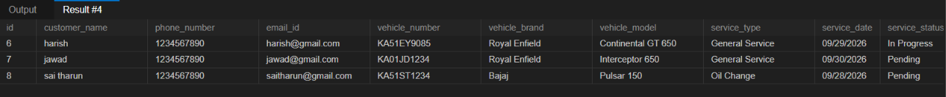

----------------------------------------------------------------------------------------------------------------

9. Backend Server
Server.js
const express = require("express");
const path = require("path");
const db = require("./db");
const app = express();
const PORT = 3000;
app.use(express.json());
app.use(
express.urlencoded({
extended: true
})
);
app.use(
express.static(
path.join(__dirname, "public")
)
);

--------------------------------------------------------------------------------------------------------------

10. CRUD OPERATION
The project implements all four basic database operations.

Operation | HTTP Method | Purpose
Create | POST | Add service record
Read | GET | Display service records
Update | PUT | Edit service record
Delete | DELETE | Delete service record

CREATE → POST
READ → GET
UPDATE → PUT
DELETE → DELETE
--------------------------------------------------------------------------------------------------------------
11.CRUD OPERATION
- Server.js
create
app.post("/api/services", async (req, res) => {
try {
const {
customer_name,
phone_number,
email_id,
vehicle_number,
vehicle_brand,
vehicle_model,
service_type,
service_date,
service_status
} = req.body;
// VALIDATION
if (
!customer_name ||
!phone_number ||
!email_id ||
!vehicle_number ||
!vehicle_brand ||
!vehicle_model ||

!service_type ||
!service_date ||
!service_status
) {
return res.status(400).json({
error:
"Please fill all fields"
});
}
// PHONE VALIDATION
if (!/^[0-9]{10}$/.test(phone_number)) {
return res.status(400).json({
error:
"Phone number must contain 10 digits"
});
}
// INSERT
const [result] = await db.query(
INSERT INTO service_records
(
customer_name,
phone_number,
email_id,
vehicle_number,
vehicle_brand,
vehicle_model,
service_type,
service_date,
service_status
)
VALUES (?, ?, ?, ?, ?, ?, ?, ?, ?)
`, [
customer_name,
phone_number,
email_id,
vehicle_number,
vehicle_brand,
vehicle_model,
service_type,
service_date,
service_status
]
);
res.status(201).json({
message:
"Service record added successfully",
id:
result.insertId
});
} catch (error) {
console.error("POST ERROR:", error);
res.status(500).json({
error:
"Failed to add service record"
});
}
});

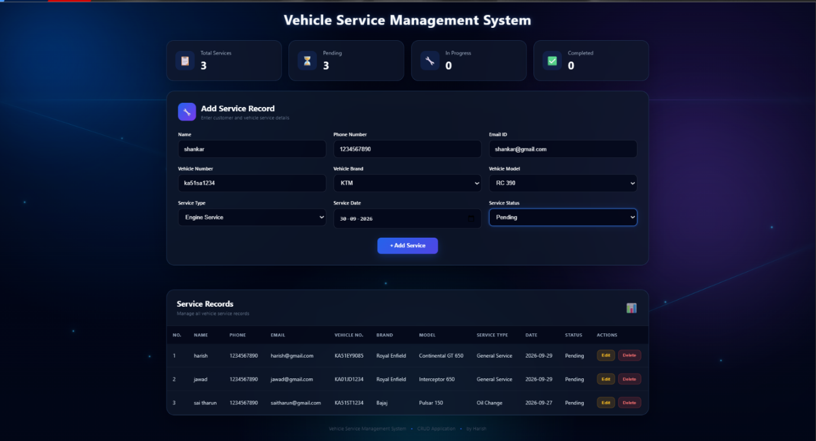
--------------------------------------------------------------------------------------------------------------
- read
app.get("/api/services", async (req, res) => {
try {
const [rows] = await db.query(`
SELECT *
FROM service_records
ORDER BY id ASC
`);
res.json(rows);
} catch (error) {
console.error("GET ERROR:", error);
res.status(500).json({
error:
"Failed to load service records"
});
}
});

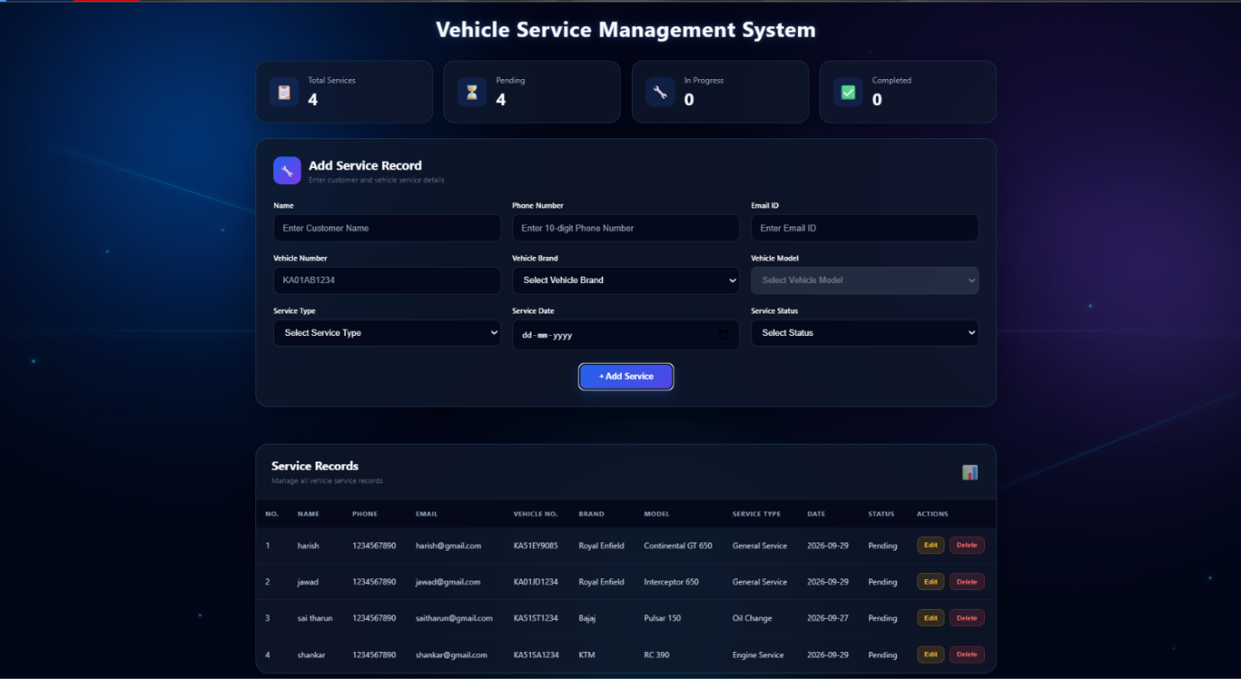
--------------------------------------------------------------------------------------------------------------
- update
app.put("/api/services/:id", async (req, res) => {
try {
const { id } = req.params;
const {
customer_name,
phone_number,
email_id,
vehicle_number,
vehicle_brand,
vehicle_model,
service_type,
service_date,
service_status
} = req.body;
// VALIDATION
if (
!customer_name ||
!phone_number ||
!email_id ||
!vehicle_number ||
!vehicle_brand ||
!vehicle_model ||
!service_type ||
!service_date ||
!service_status
) {
return res.status(400).json({
error:
"Please fill all fields"
});
}
if (!/^[0-9]{10}$/.test(phone_number)) {
return res.status(400).json({
error:
"Phone number must contain 10 digits"
});
}
// UPDATE
const [result] = await db.query(
`
UPDATE service_records
SET
customer_name = ?,
phone_number = ?,
email_id = ?,
vehicle_number = ?,
vehicle_brand = ?,
vehicle_model = ?,
service_type = ?,
service_date = ?,
service_status = ?
WHERE id = ?
`,
[
customer_name,
phone_number,
email_id,
vehicle_number,
vehicle_brand,
vehicle_model,
service_type,
service_date,
service_status,
id
]
);
if (result.affectedRows === 0) {
return res.status(404).json({
error:
"Service record not found"
});
}
res.json({
message:
"Service record updated successfully"
});
} catch (error) {
console.error("PUT ERROR:", error);
res.status(500).json({
error:
"Failed to update service record"
});
}
});

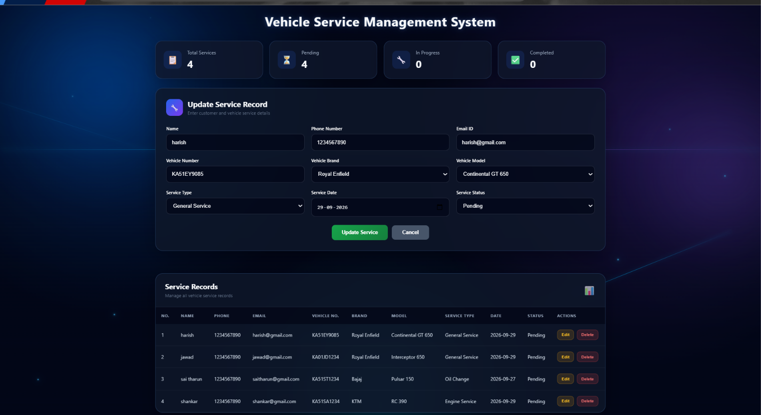
❗for better understanding see this status bar
before update

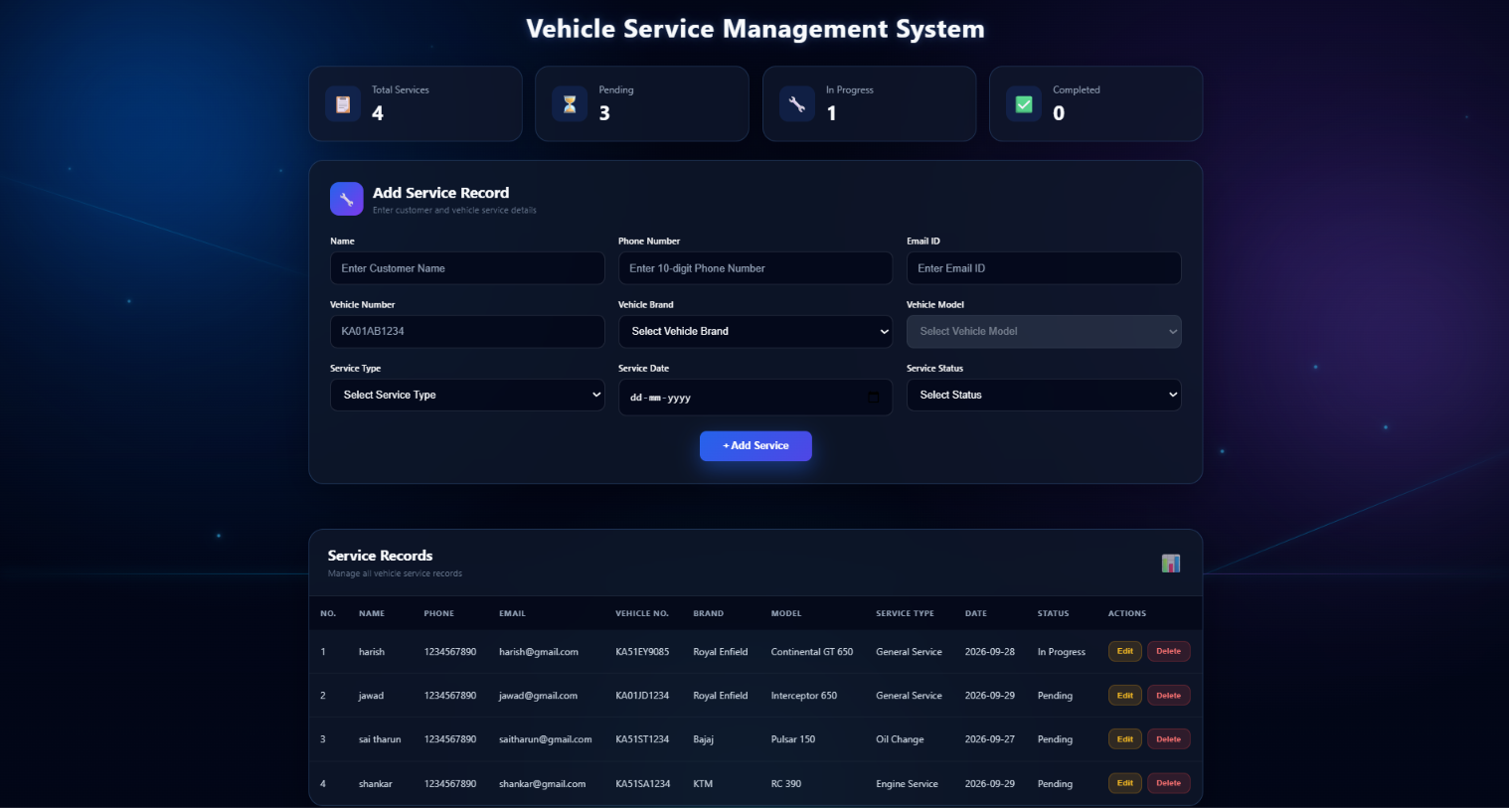
After update

--------------------------------------------------------------------------------------------------------------
- delete
app.delete("/api/services/:id", async (req, res) => {
try {
const { id } = req.params;
const [result] = await db.query(
`
DELETE FROM service_records
WHERE id = ?
`,
[id]
);
if (result.affectedRows === 0) {
return res.status(404).json({
error:
"Service record not found"
});
}
res.json({
message:
"Service record deleted successfully"
});
} catch (error) {
console.error("DELETE ERROR:", error);
res.status(500).json({
error:
"Failed to delete service record"
});
}
});

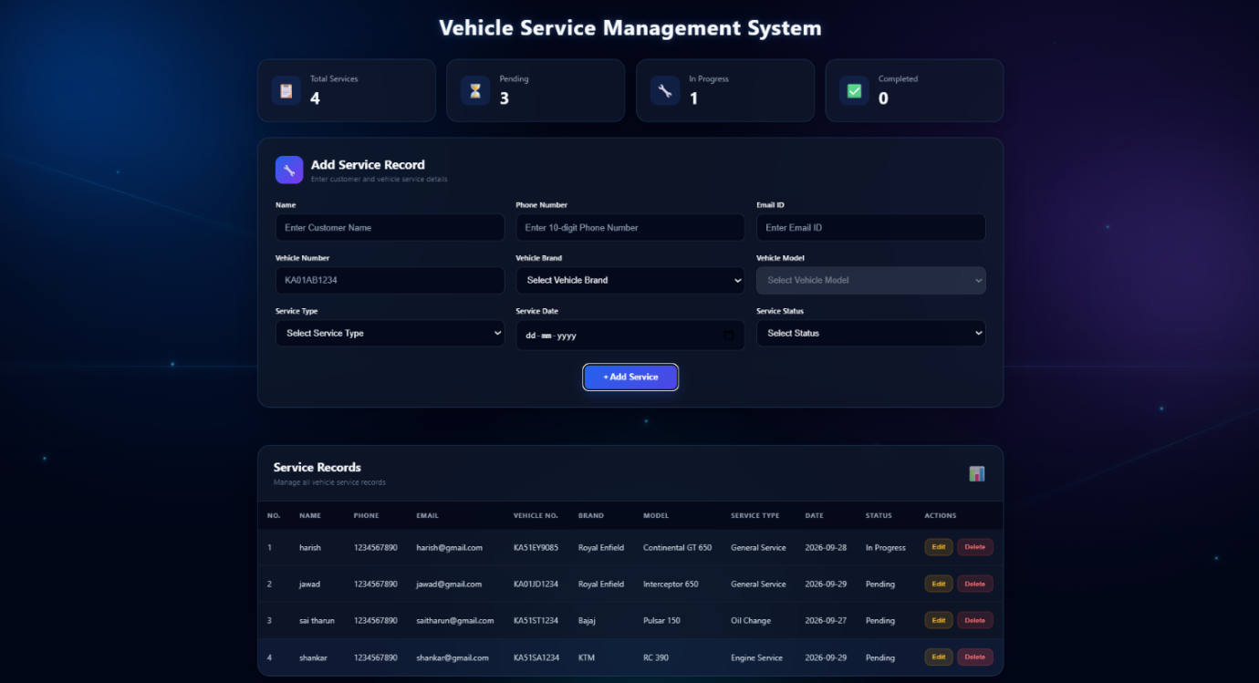
before delete

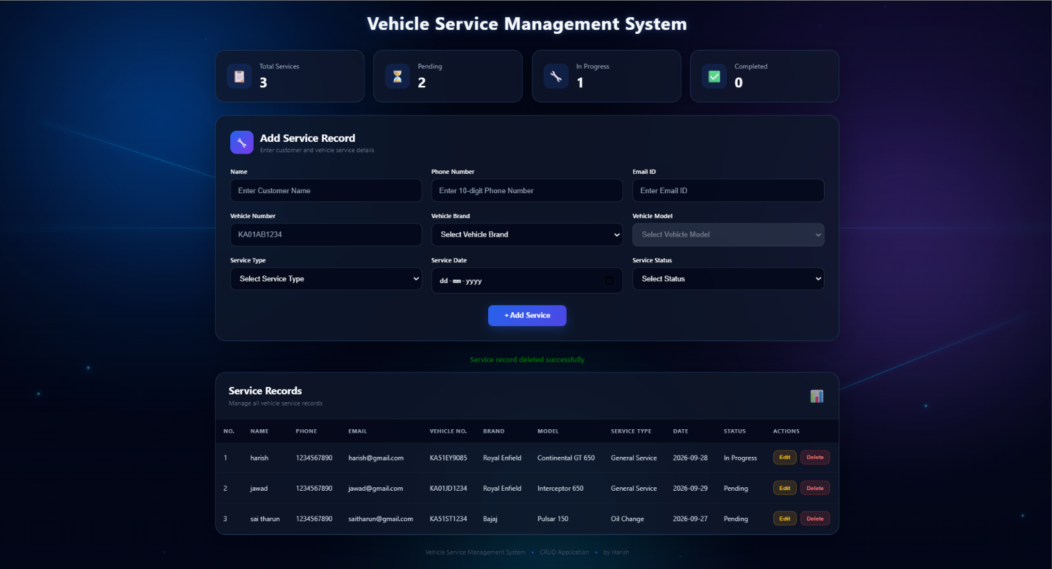
after delete

--------------------------------------------------------------------------------------------------------------

12.Package Configuration –
package.json
The package.json file contains the basic configuration of the Node.js project. It defines the project name, version, start command, and required dependencies.

{
"name": "vehicle-service-management",
"version": "1.0.0",
"description": "Vehicle Service Management System",
"main": "server.js",
"scripts": {
"start": "node server.js"
},
"dependencies": {
"express": "^5.1.0",
"mysql2": "^3.14.3"
}
}

13. Running the Project

The project is started using:

npm start

The server runs at:

http://localhost:3000

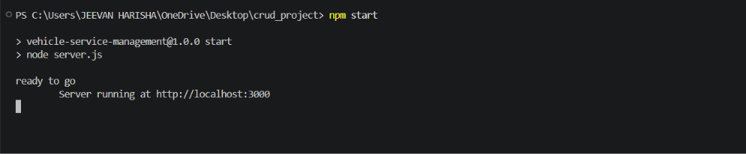
--------------------------------------------------------------------------------------------------------------
14.Final Output
The completed Vehicle Service Management System provides a simple interface for managing vehicle service records. The application connects the frontend with a Node.js/Express backend and MySQL database and supports complete CRUD functionality.

******* This is the end *******

